**Name: احمد محمد عبد الغني علي شعله**

**Section: 6 group: 1**

**ID: 127**

***Topic: programming Languages***

***Why Should I Learn Coding?***

discuss this topic and its applications

A lot of people before entering into the programming field are curious to know how things work behind the scene? How within a few second Google give us a search result whatever we are looking for? How we are able to connect to someone on facebook around this world? How Google Maps really works to give us direction anywhere in this world? All the above reasons inspire a non-programmer to choose this field. Today we all are dependent on technology in our daily life, for entertainment, for communication, and for everything but very few people know how to read and write code. If you are already coding for years, you will be able to apply this skill beyond your computers. We are surrounded by a lot of problems and coding has given us a lot of solutions in the real world. It doesn’t matter if you are a non-programmer, beginner or experienced person, there are multiple reasons you should learn to code.



Home page

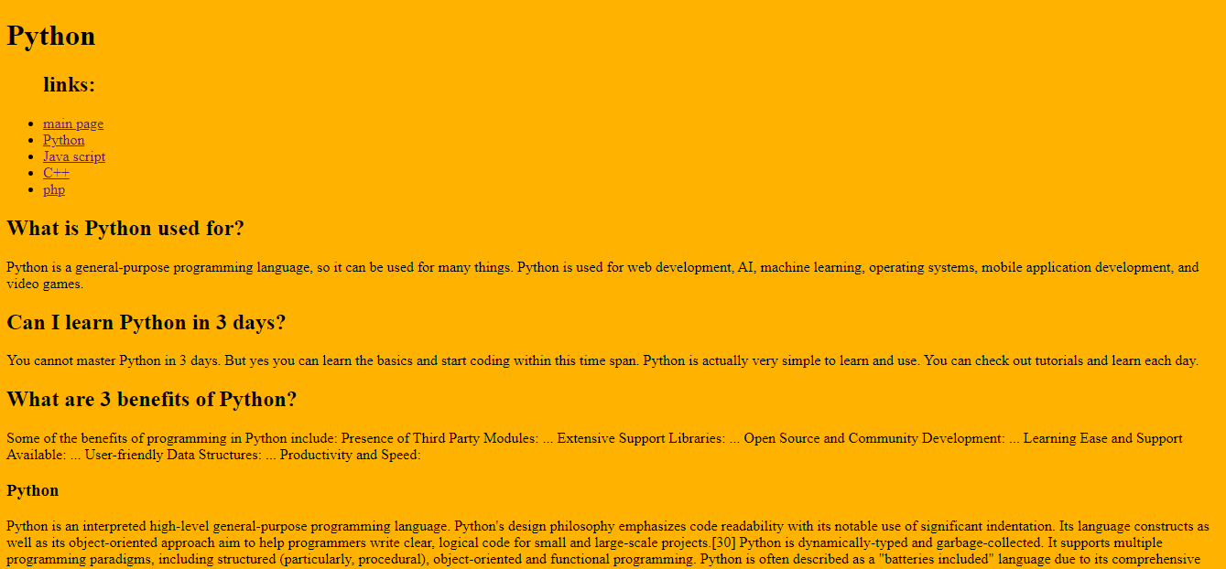

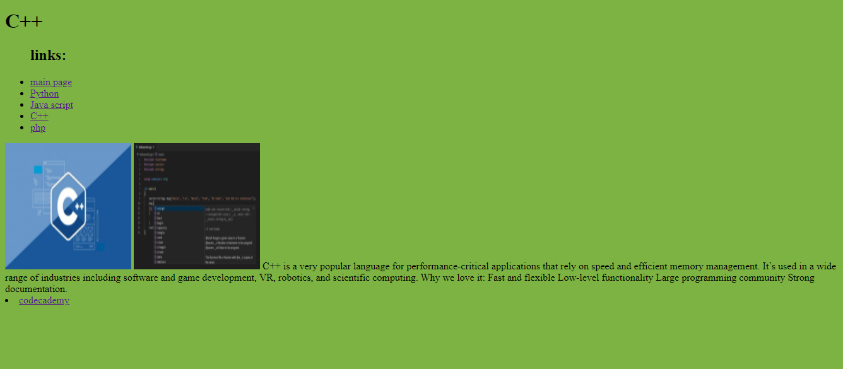

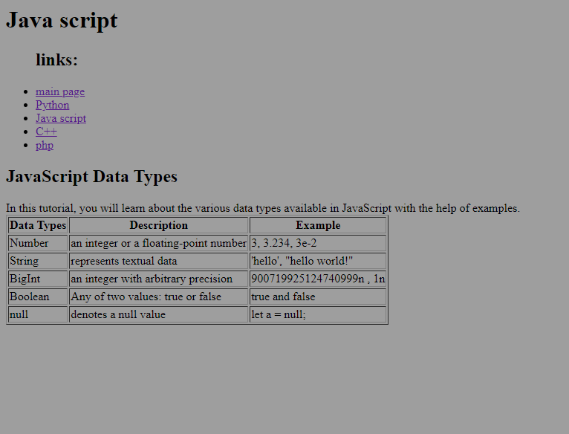

s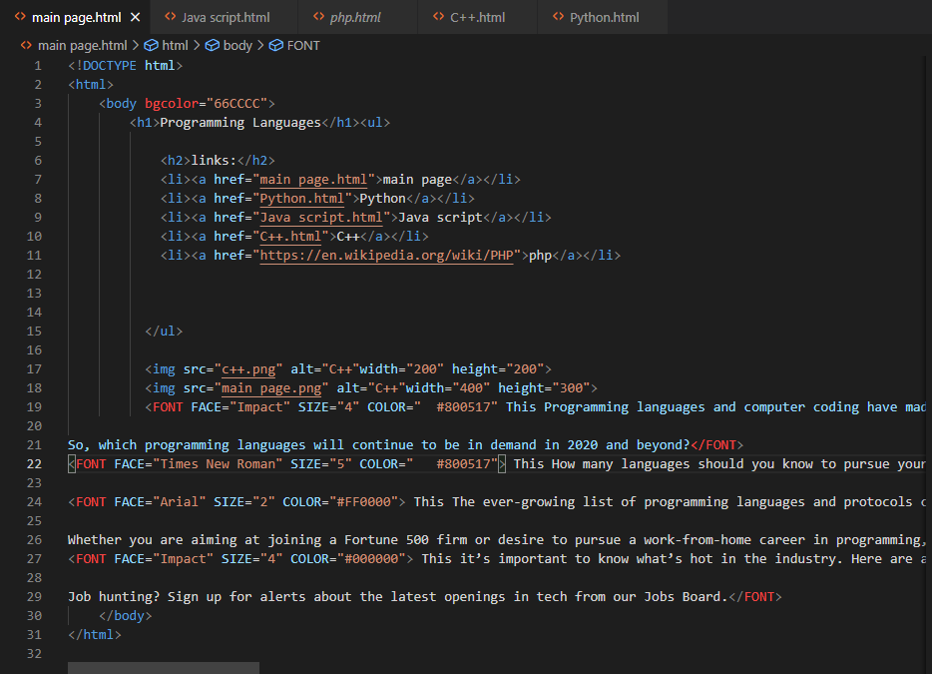

source code for home page

